KLU GLUG REPORT

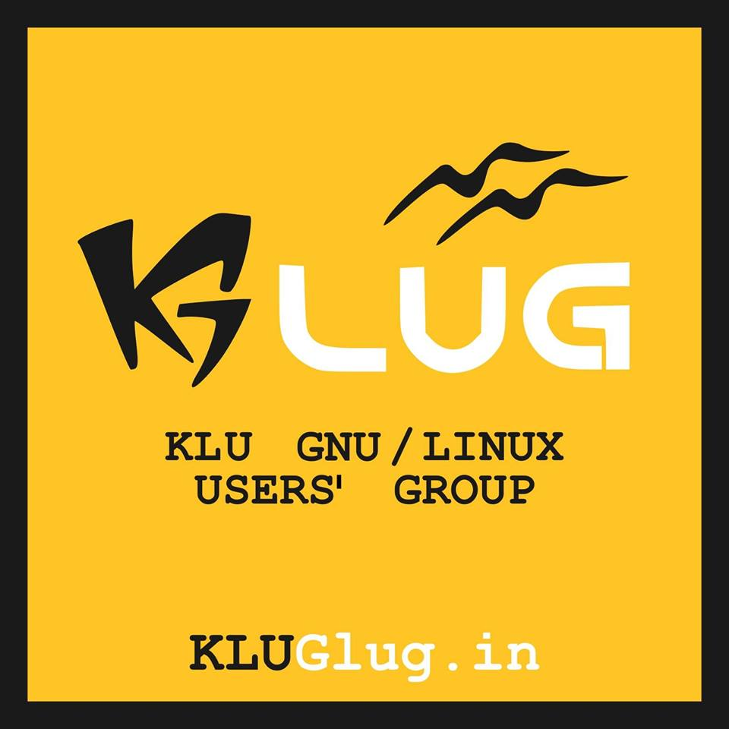

Odd Sem

24th May 2016 - 7th June 2016
Summer Camp

As a part of Internship students attended the summer camp conducted by Swecha and learned various technologies like Linux Administration, GIS, Django, Drupal, Arduino, Kdenlive, GIMP, Version control and GIT, and group discussions on various topics like farmers sucide,etc.

5th July 2016
Introduction to KLUG

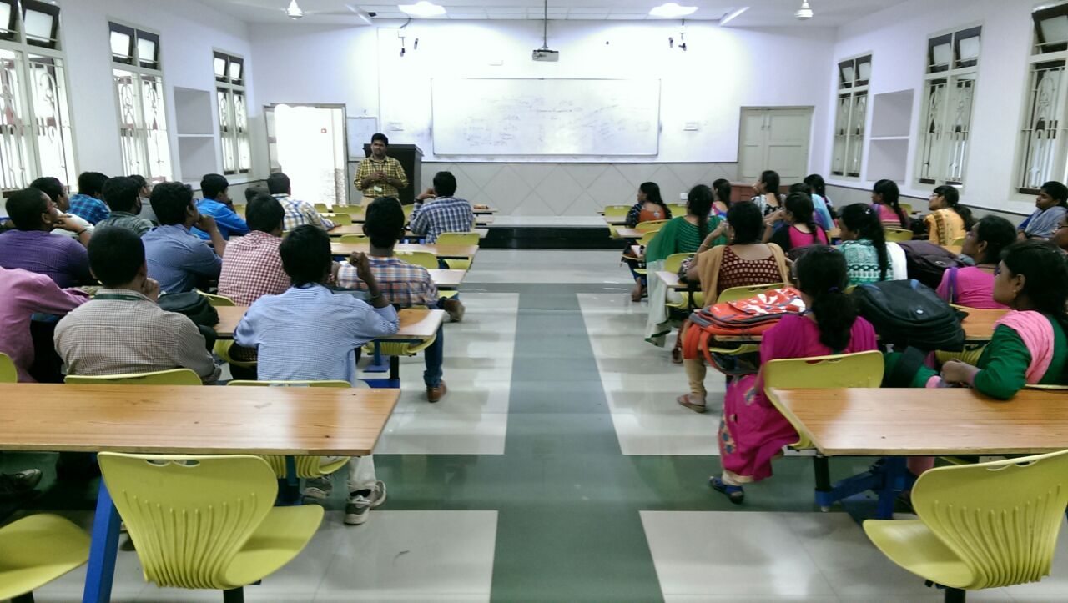

Introducing KLUG to new Volunteers and getting to know how the activities are done in KLUG , planning the future activities.Students are divided into project teams depending upon their interested area and students expresses their project ideas and suggestions are driven.

12th July 2016
Linux Installation Fest

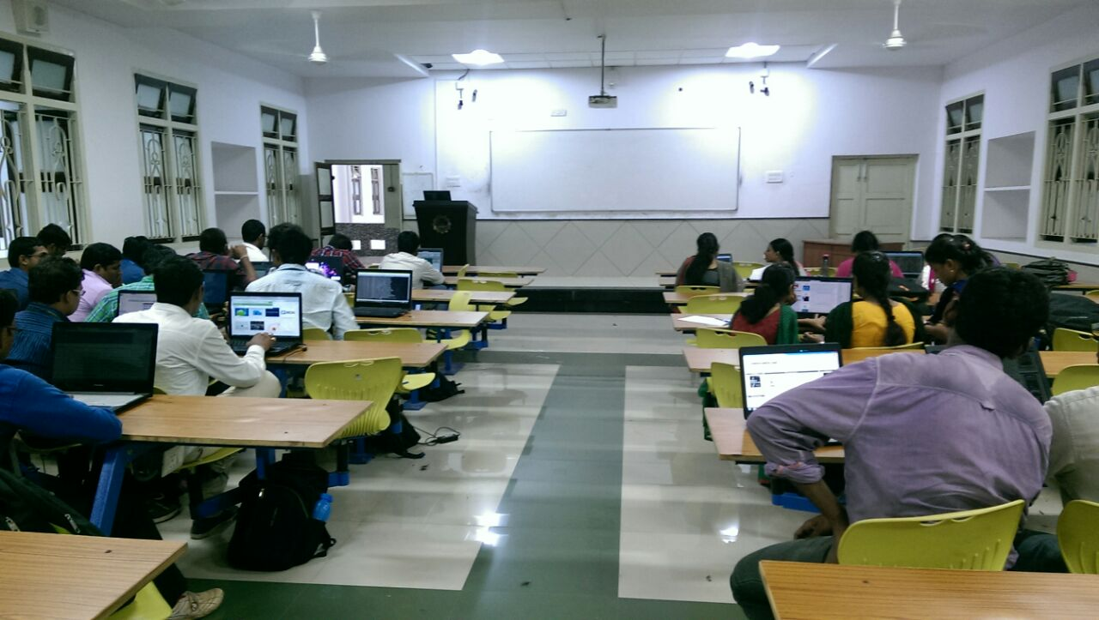

In this session the students came to know about what LINUX is, what it’s use and its advantages.
Students installed Linux in their system.

17th July 2016
Commune Lunch

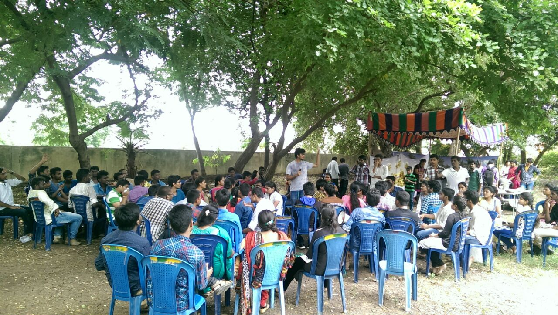

After the summer camp which is conducted by Swecha,the students from different colleges reunited and discussed about the progress of FOSS, glugs in their colleges and future plans to extend it.

19th July 2016
System Administration and discussion on survilence

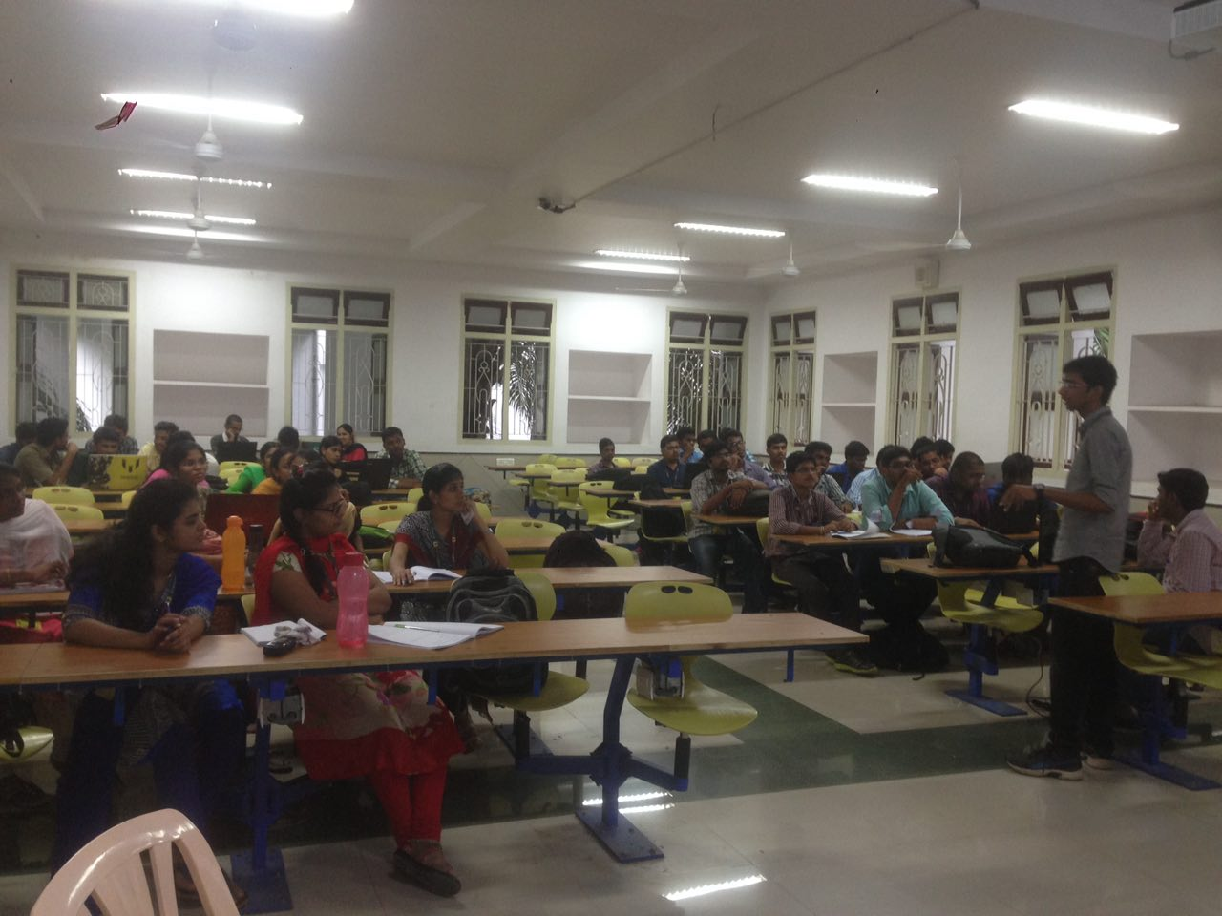

In this session the students learn about administration,file hirearchy in Linux.
Later a group discussions on internet survillence,how does it effects us and mersures to prevent it.

26th July 2016
Trouble shooting Linux Machine and python programming
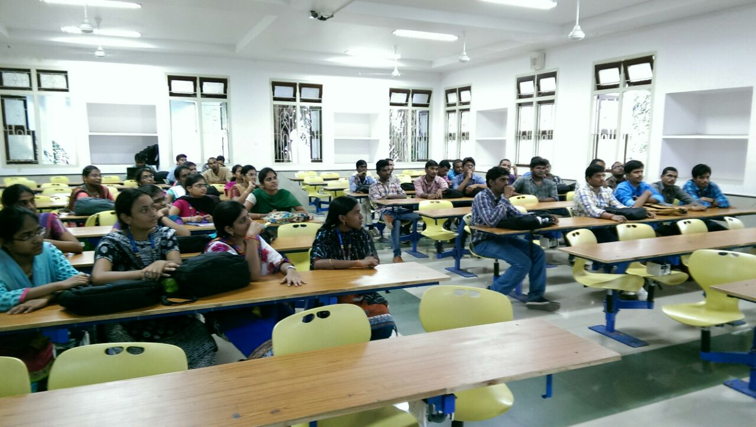

In this session students know how to slove the errors while installing of Linux and errors which are encountered while using of the Linux.

29th July 2016
Talk by Pramod

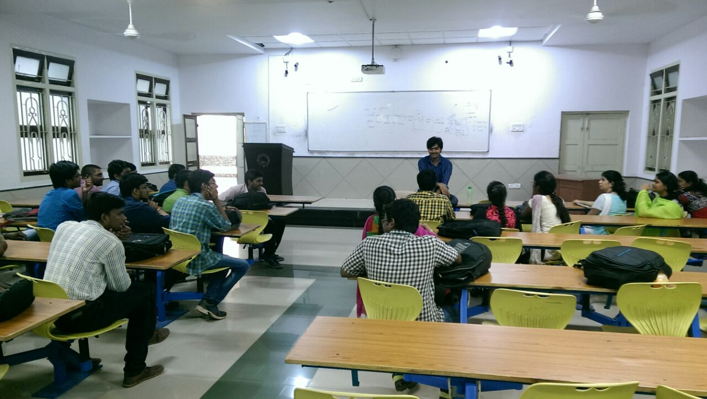
After the Summer Camp, Mr.Pramod(Project Manager ThoughtWorks) interacted with the glug attendees and discussed about the opportunities they can work on and various job opportunities.

2nd August 2016
Drupal

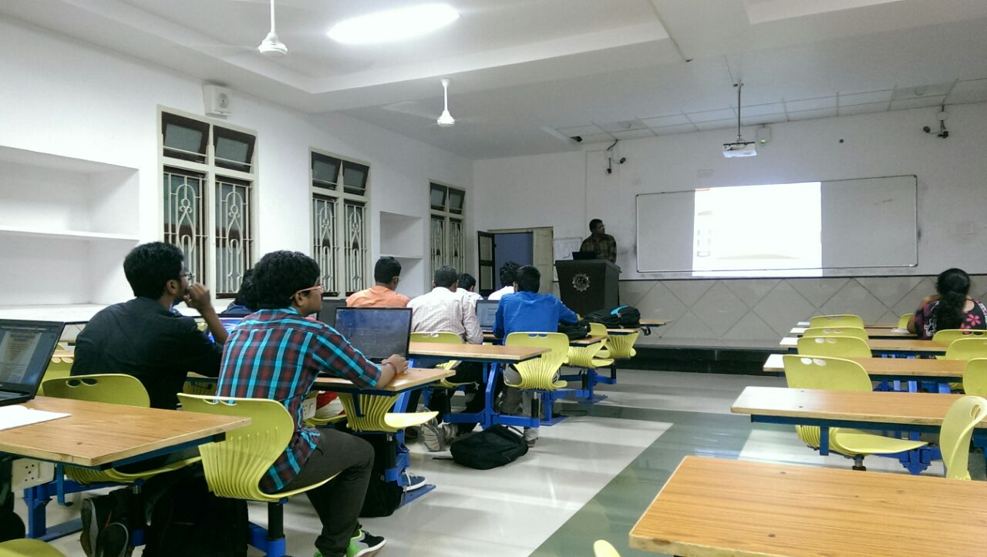
In this session the students came to know about what are web technologies and how we one can explore them and create one’s own site without codding. Students created their own web forms.

12th August 2016 - 20th August 2016
Pushkaralu Event

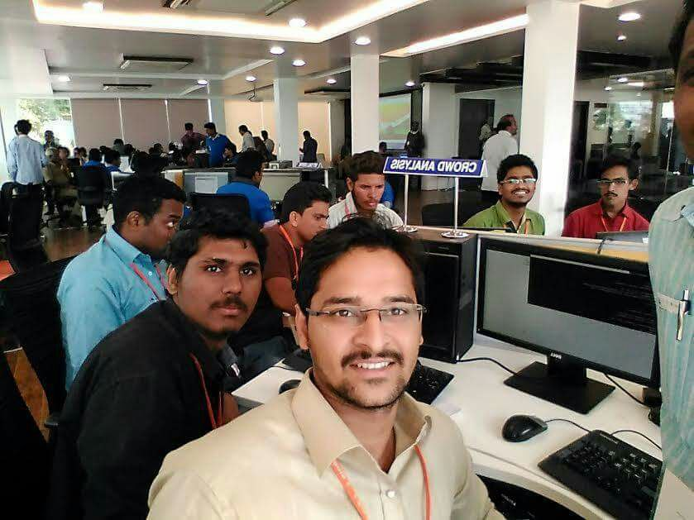

At the Krishna Pushkaralu which ocurred in August 2016. 10 of our glug members participated init as a Crowd Analyst. In this we are supposed to calculate the crowd in each ghats by Image processing.

9th September 2016
BalaSwecha

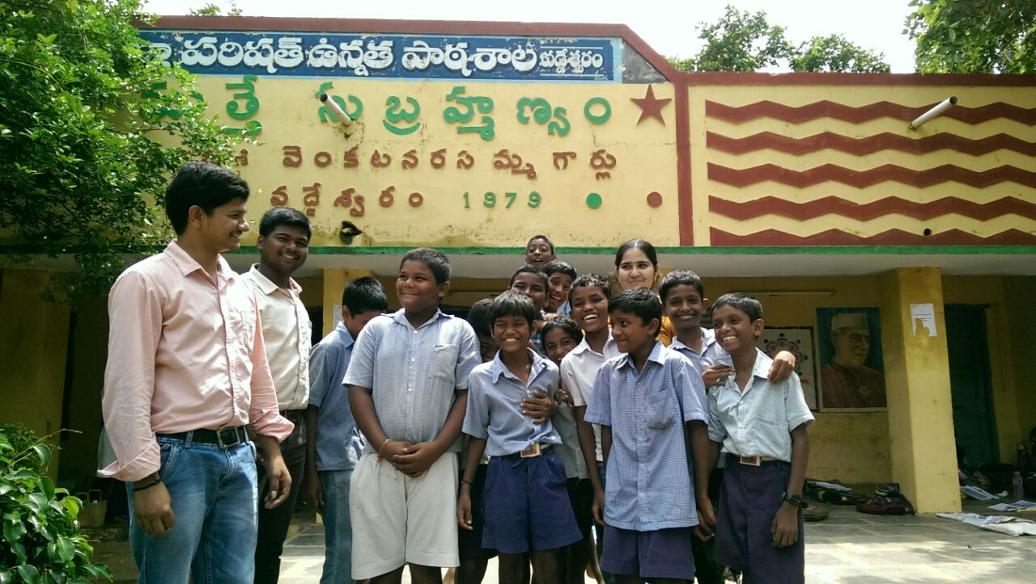

In BalaSwecha the students will go to the Government schools and teach about what computers are and teach the subjects using simulation tools in BalaSwecha OS.

20th September 2016
Discussion on Security Issues

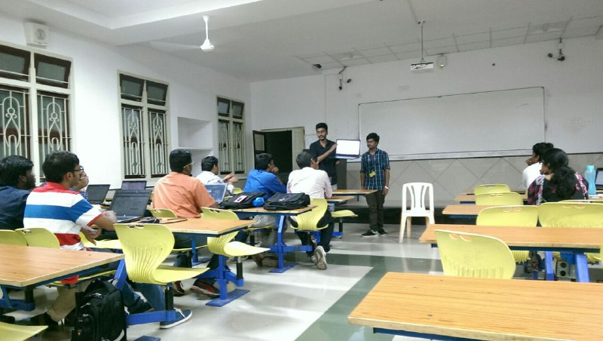

In this session students know why Security is needed, the necessary to stay secure from malwares,trojans,spywares, etc and application to prevent them.

18th October 2016
Raspberry Pi

no pic write content

8th November 2016
Aaron Day

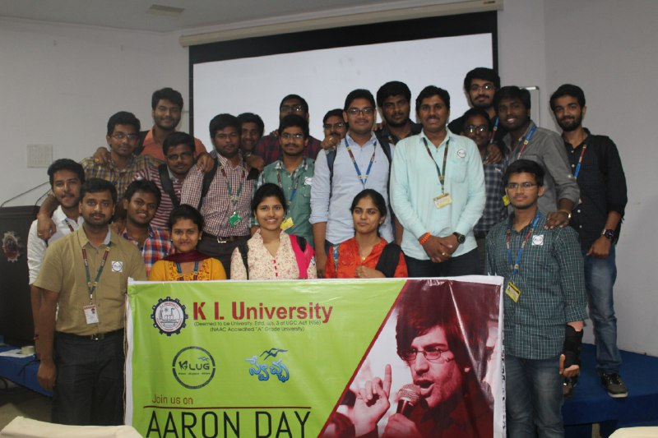

As a tribute to AARON SWARTZ the Internets’ Own Boy, Kluglug held various activites like logo quiz,group discussion on Patents and copy rights,documentry, etc on his birthday.

31st November 2016 - 2nd December 2016
Tech Days

In these Tech Days members from SWECHA organistion along with Klug members had taken various sessions on what is FOSS,Linux,Drupal and many for students of KLU

1st-3rd December 2016
Assembly

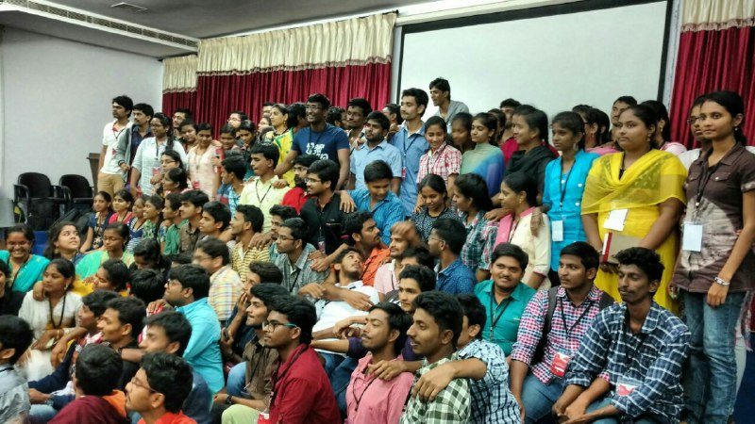

Even Sem

20th December 2016
Intro to Klug,Future Plans ,Project Teams

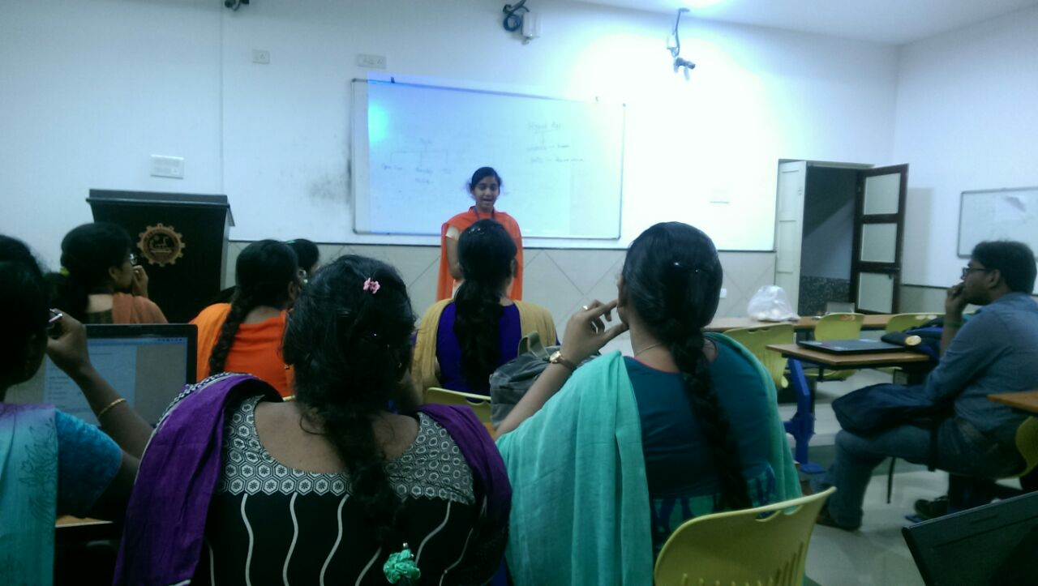
Introducing KLUG to new Volunteers and getting to know how the activities are done in KLUG , planning the future activities.Students are divided into project teams depending upon their interested area and students expresses their project ideas and suggestions are driven.

24th December 2016
Re-Engineering Digital India

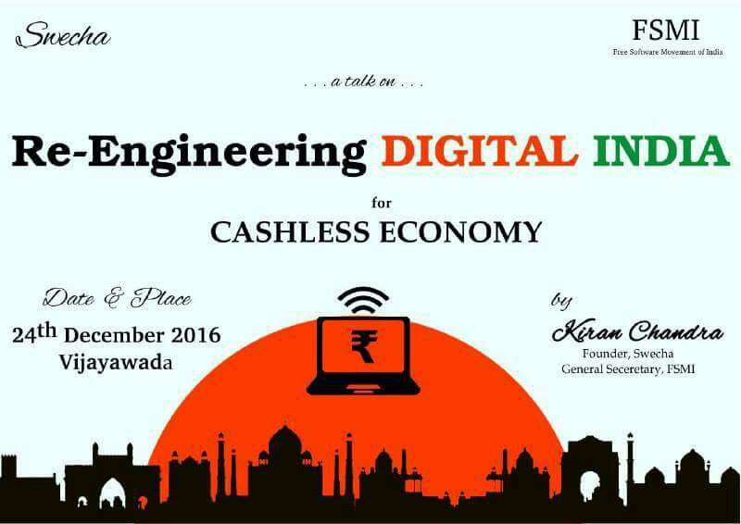

A Talk by Kiran Chandra (General Secretary of Free Software Movement of India)on Re-Engineering digital India for cashless economy where all the students of KLUG took an active part.

27th December 2016
Session on Git , Wikimedia

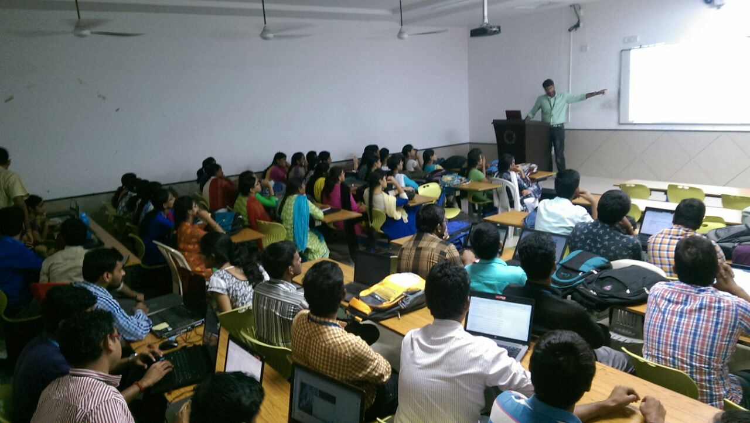
This session is dealt with System Administration in Linux Operaing System and got an overview of Linux based systems and how to do different actions on Operating System through command line and had an Introduction about Version Control and GIT.

1st January 2017
Potluck Lunch

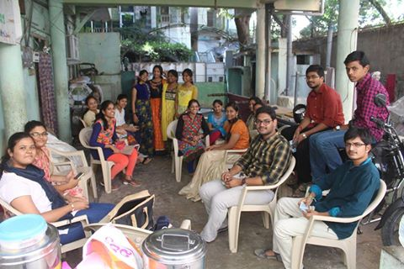

Potluck Lunch is conducted in Guntur by the KLUG Volunteers where each person gets a dish prepared by them and all the dishes are shared where we finally connect this activity to the Philosophy

3rd January 2017
Hosting Git Project , Intro to FOSS ,
Localisation Activity , Drupal Form

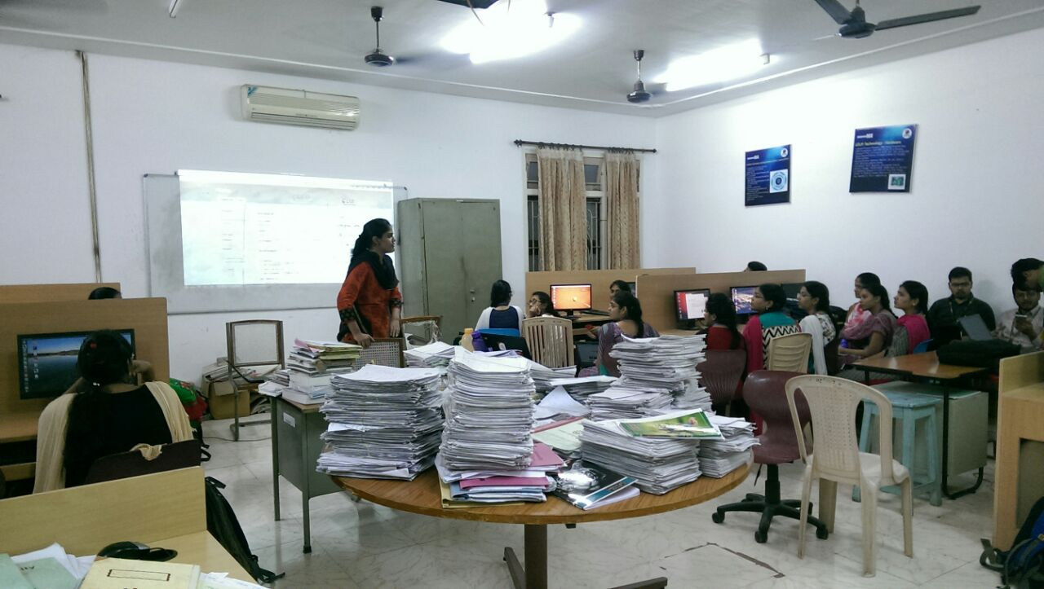
This session is about Introducing FOSS community principles and students also worked on Drupal and created basic web forms.And got to know about the localization and translating Freedom Box into Telugu

6th January 2017
Basic understanding of Freedom Box Project
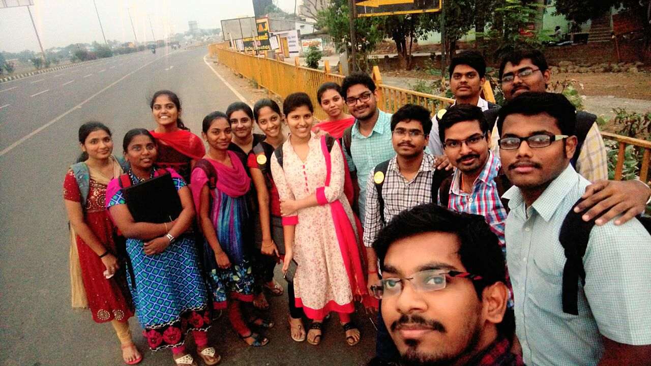

This session is about getting introduced to freedom box, its advantages , the role it has been playing in digitalizing rural India, deployment of freedom box and the ways freedom box can be developed.

7th January 2017
Field activity for Freedom box project
signal testing analysis , authentication provision

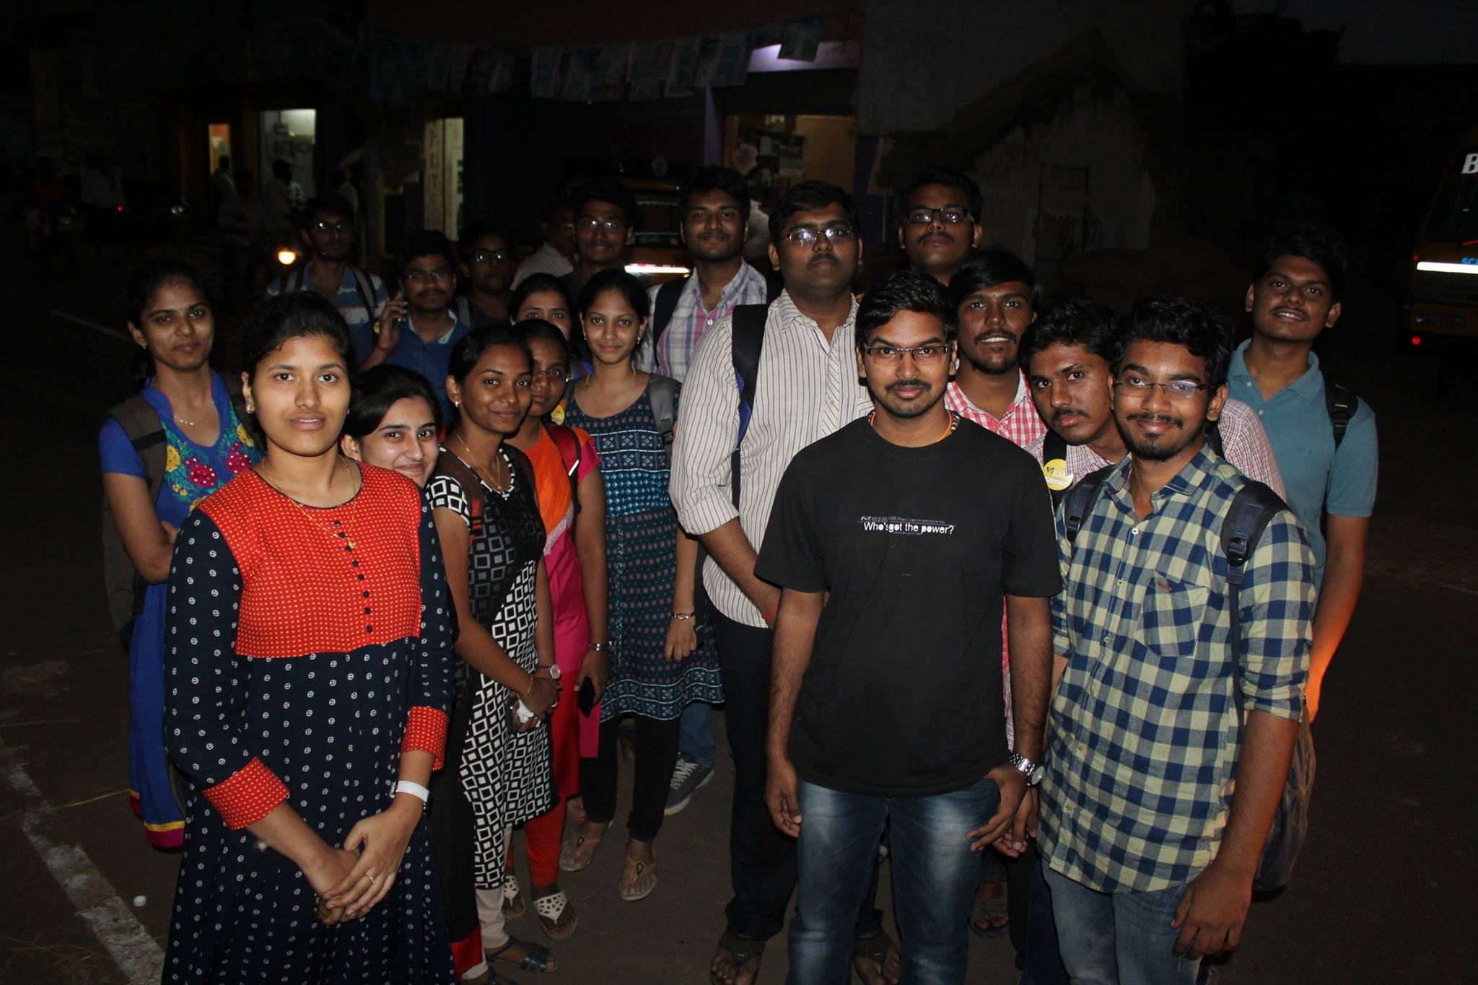

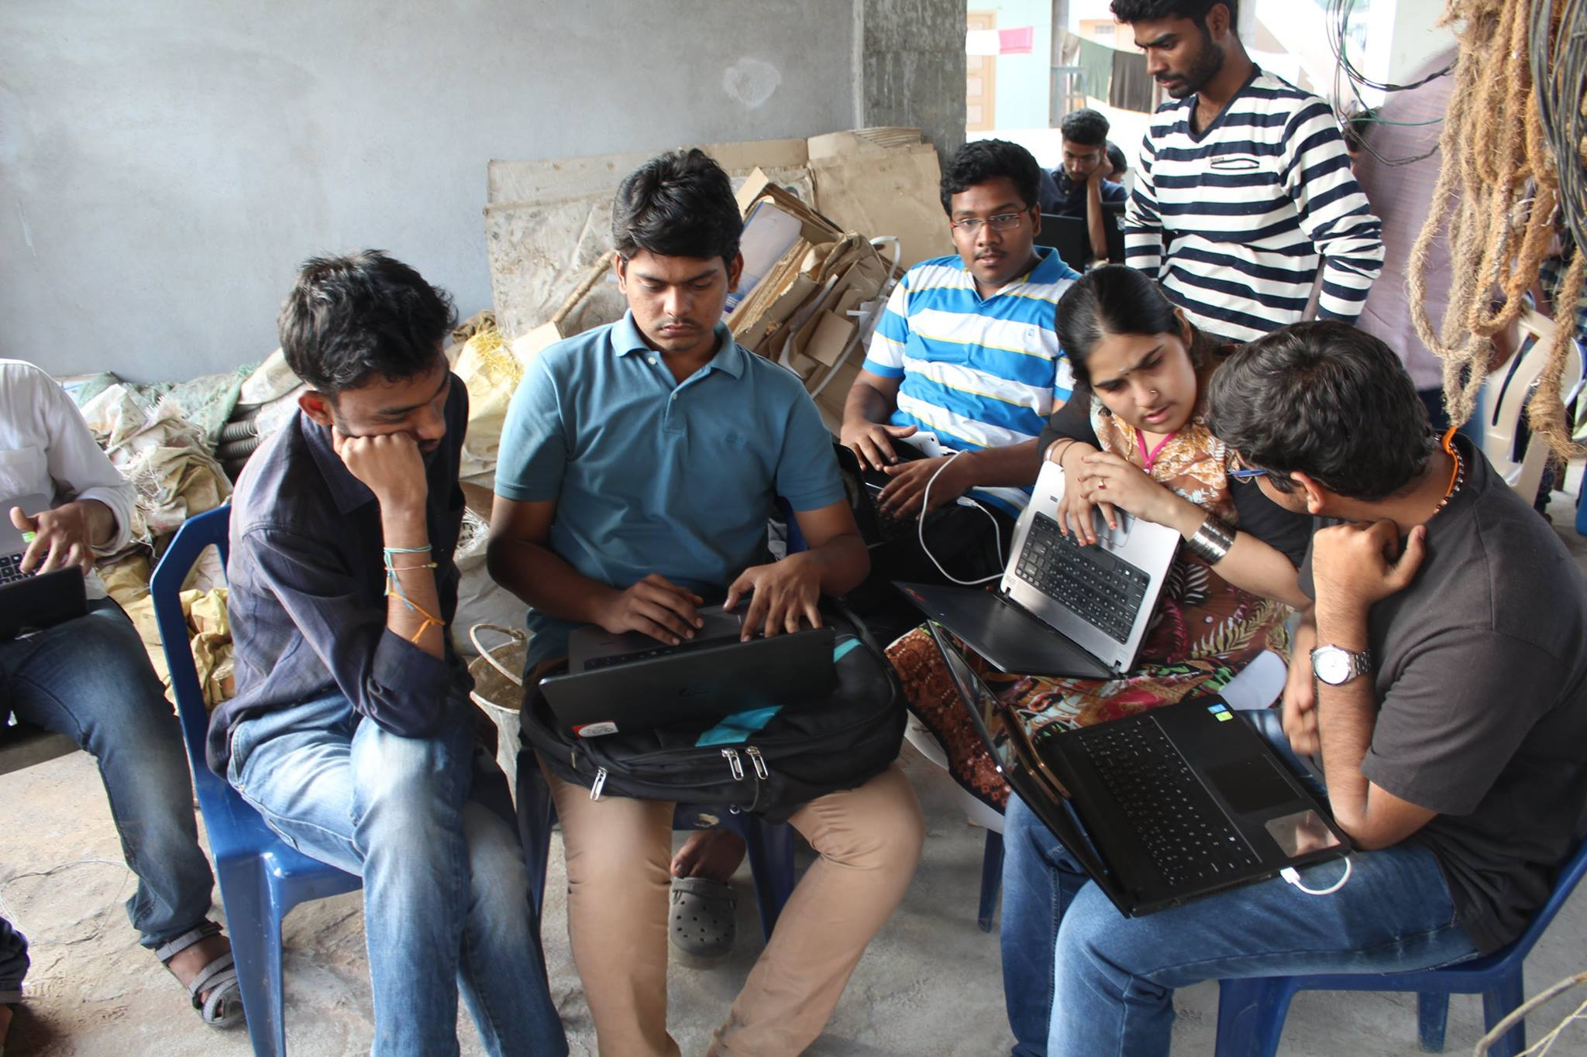

8th January 2017
Rally against Women Molestation

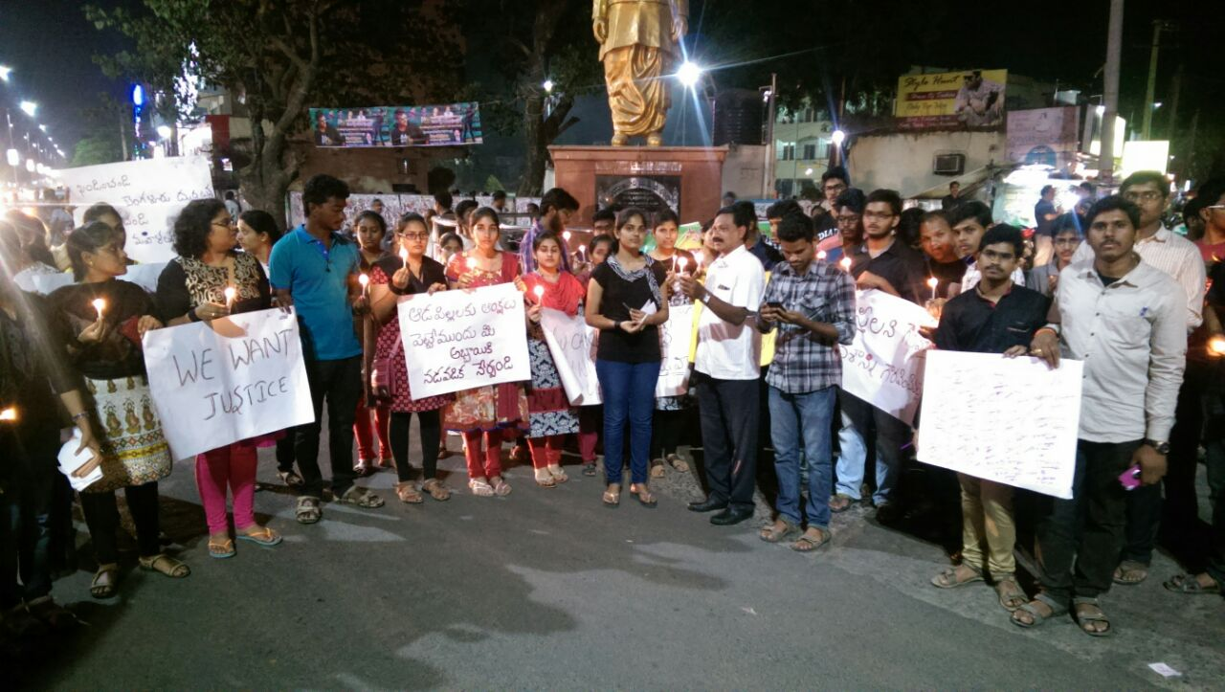

This was held in Guntur by KLUG volunteers where all the students gathered and took part in rally and created awareness among people about women molestation going on in our country.

10th January 2017
Session on Inkscape
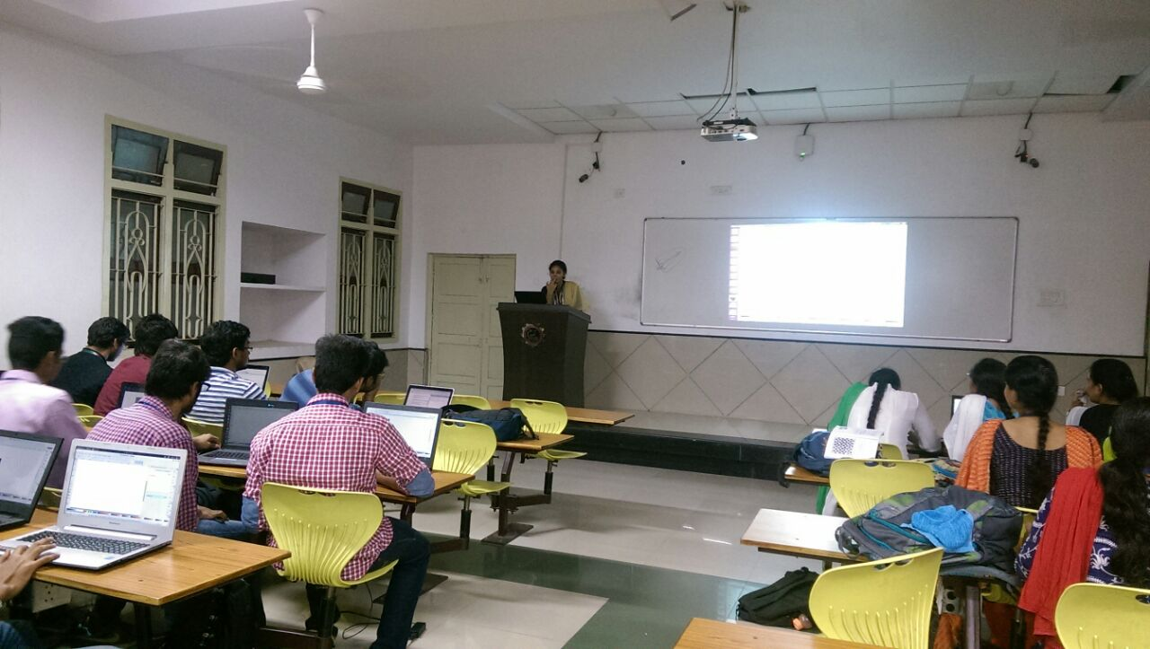

This session is about getting introduced to inkscape which is vector 3-D tool.The students got to know what is inkscape and how it can be used to make logos , posters and 3-D creations.

11th January 2017
Overview of Cashless Economy
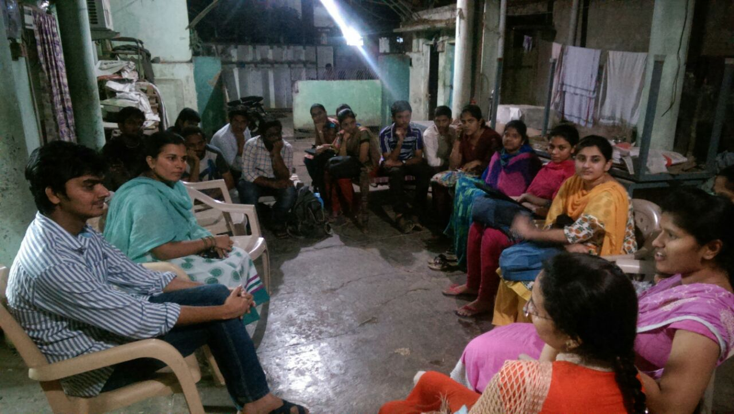

This was held in Guntur by KLUG volunteers where all the students gathered and took part in the discussion on cashless Economy.

21st January 2017
Glug Office Projects to work on

This session is about briefing the works that should be done by KLUG and distributing works among the members of KLUG

26th-28th January 2017
4ccon
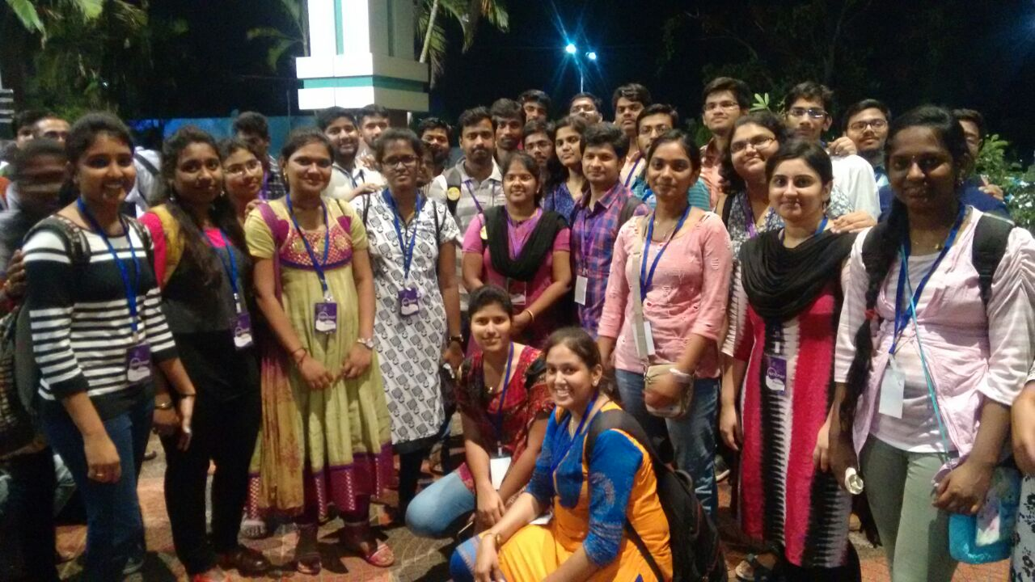

110 Students from KLU attended different workshops dealt with emerging technologies like elixir,R,Go Lang and conference held in chennai by Free software movement of India

31st January 2017
Exchanging different learning experiences at 4ccon and at different workshops

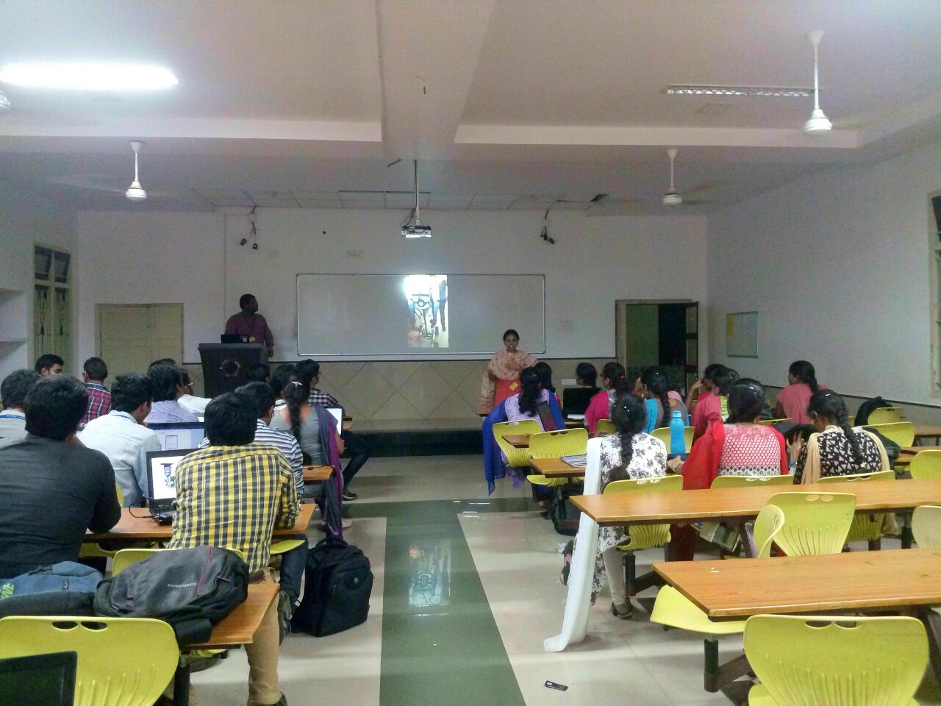

This session was about getting introduced to the trending technologies like elixer,docker and machine learning.The students got to know about the basics of these technologies how and where they are used.

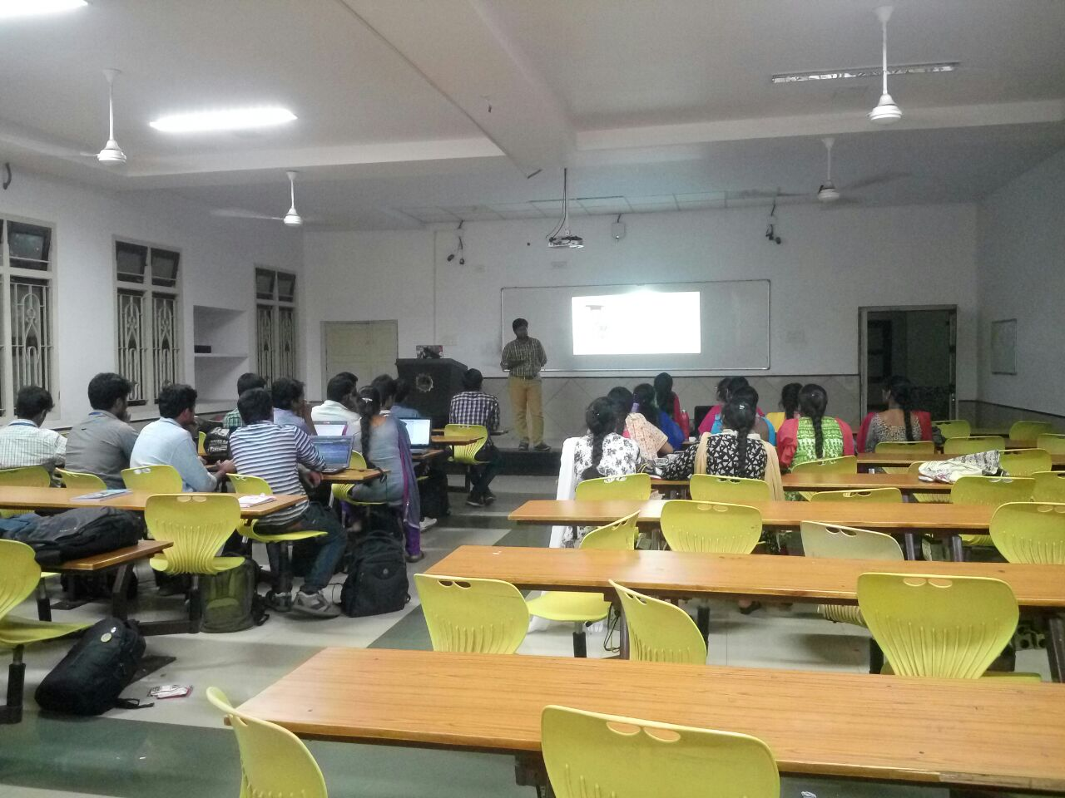

7th February 2017
Session on GO Lang
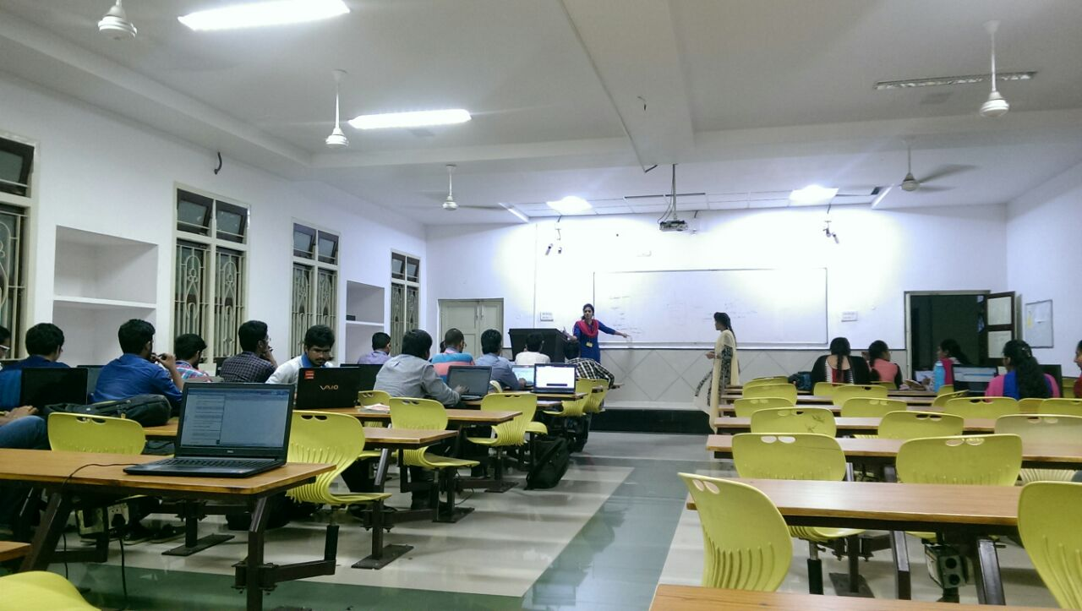

This session was about getting introduced to Golang which is programming language.Students through this session got to know about the basics , functionality and how it is being used in various companies .

21st February 2017
Localisation Event and Basic usage of Social Media

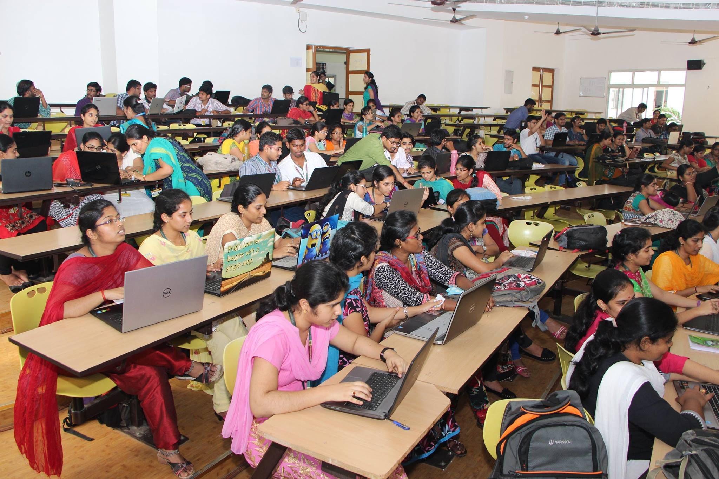

This Session was conducted on the eve of International Mother Tongue Day. The students got introduced how technology can be used for rural India that is how things can be converted into mother tongue for the ease of people.Through this, students got to know about localization and also about effective posting images in social media

25th -26th February 2017
Freedom Fest

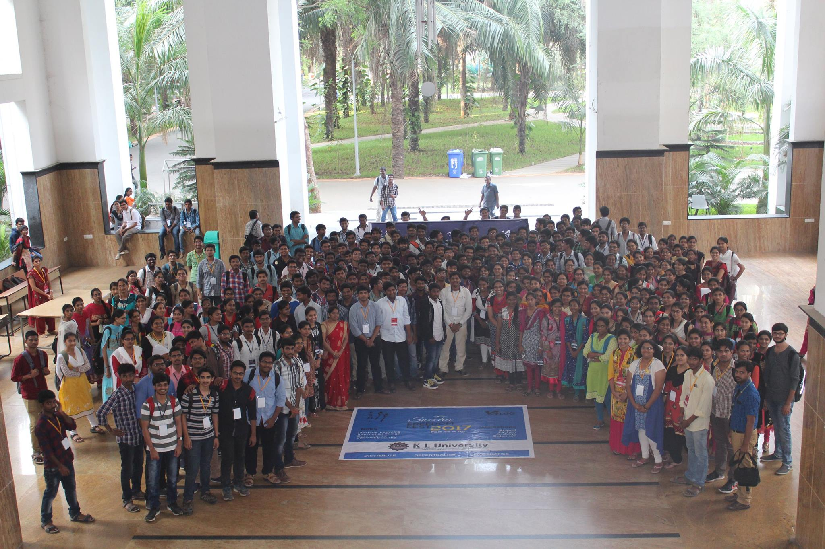

Freedom Fest is conducted by KLUG with 400
participants from in and around KLU.Sessions on Aurdino,Drupal,selenium and python were dealt.Technical Talks include Machine Learning,Data science,IOT and survillence

28th February 2017
Review of Freedom Fest and Performing some tasks on linux terminal

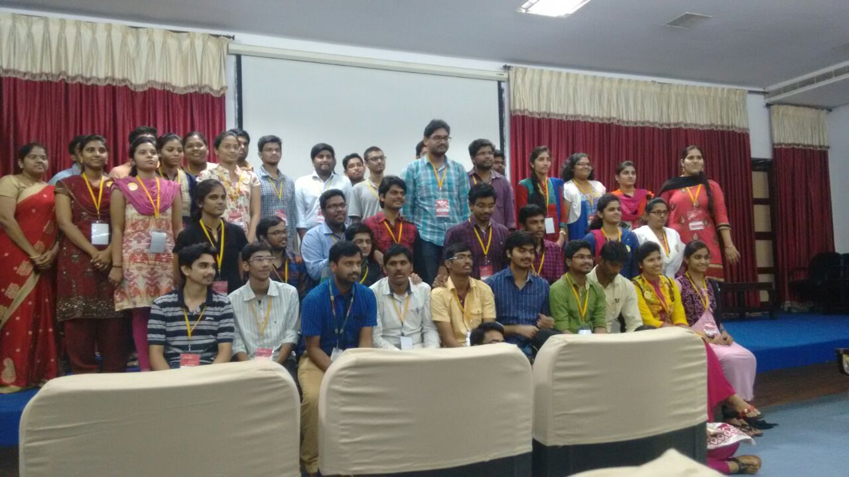

Review by all the members of KLUG after conducting Freedom Fest and small tasks were done by them in linux terminal

4th-5th March 2017
Drupal Hyderabad

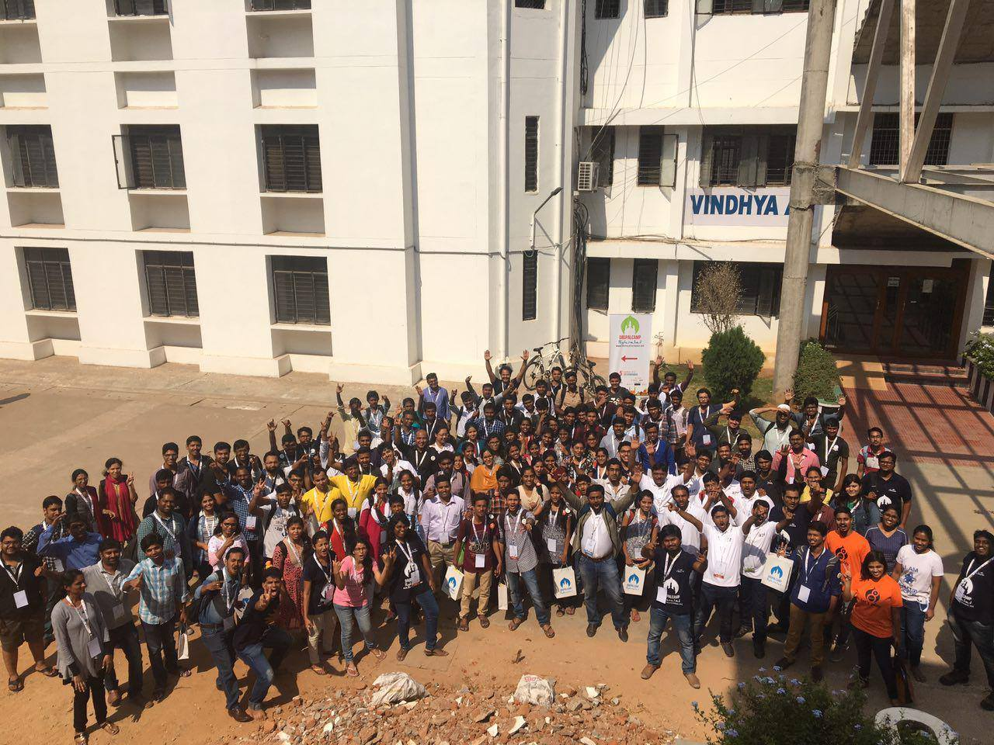

Students from KLUG attended workshop on Druapl at IIIT, Hyderabad which is the is second largest Drupal community in world next to USA.

7th March 2017
Session on Arduino

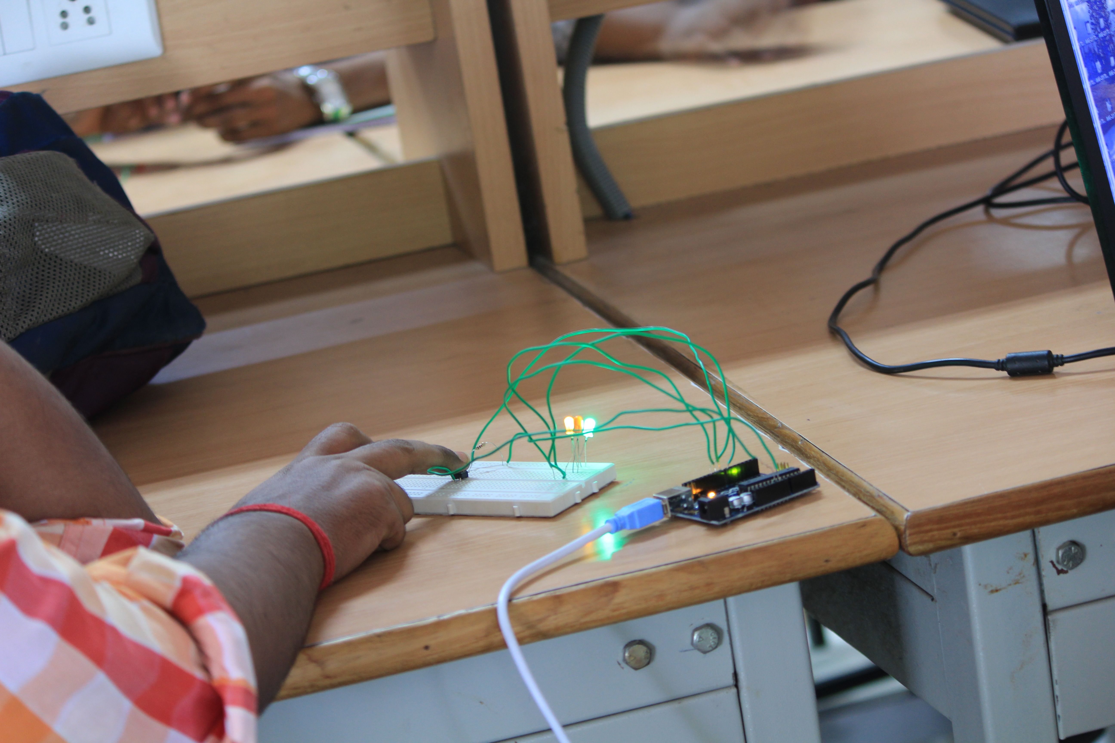

This is KLUG session on Arduino where the students were exposed to the open source computer hardware and started exploring on different sensors.

8th March 2017
Women's Day
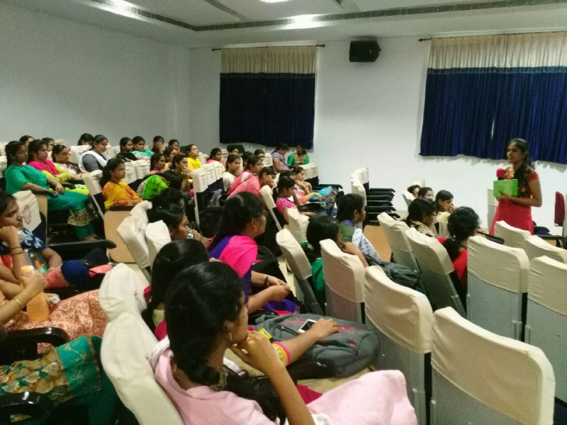

As a part of womens day IEEE organised a workshop on Ruby and Ruby on Rails where KLUG members acted as resource persons for the workshop and there are many discussions raised on different topics based on women

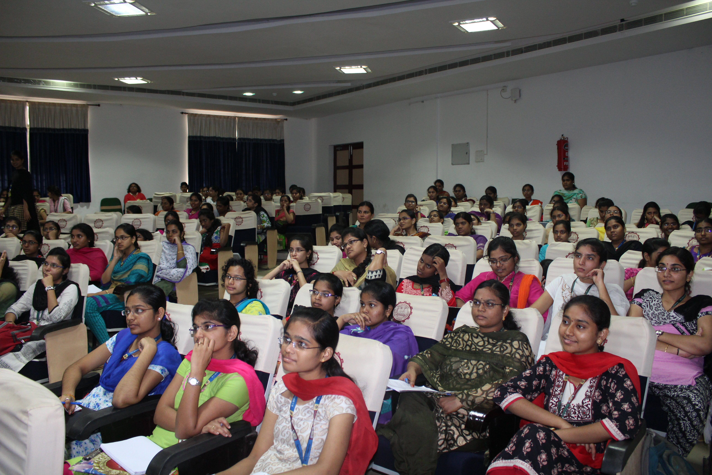

12th March 2017
Session on R-Programming and Mozilla Club Call with Regional Cordinator
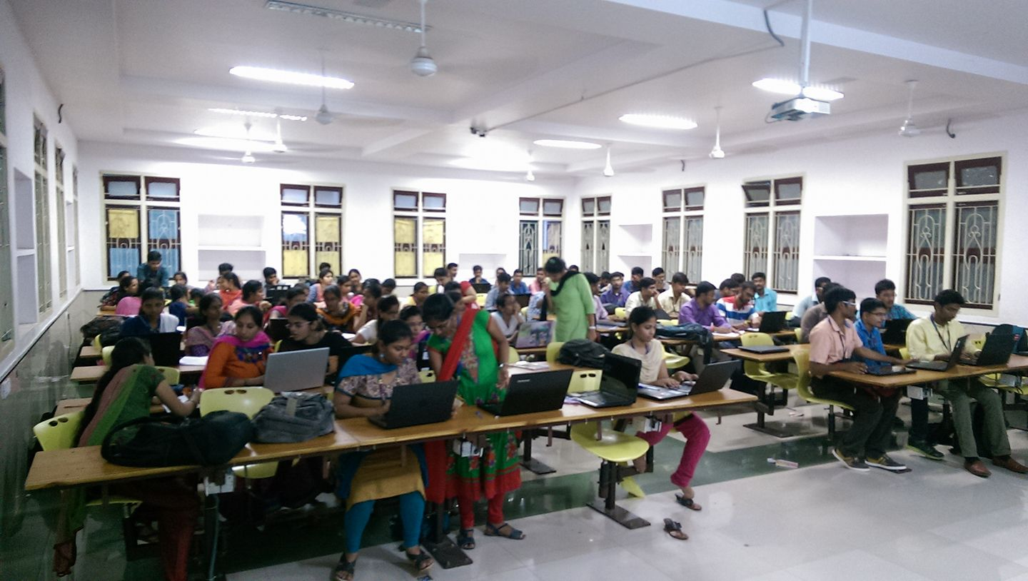

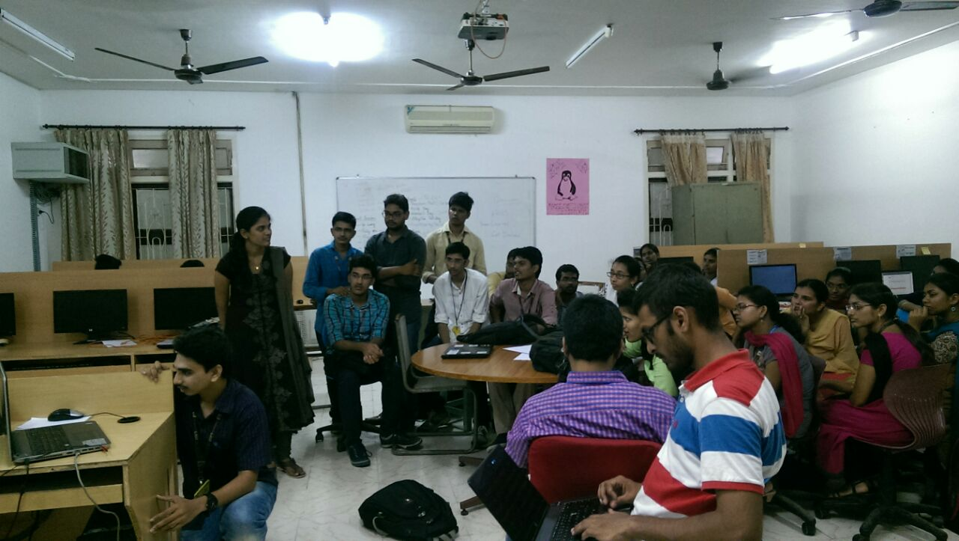
This session is dealt with R Programming and had a meet with Regional Coordinator of Mozilla Club

18th March 2017
Webinar on Rural India and Digital Age
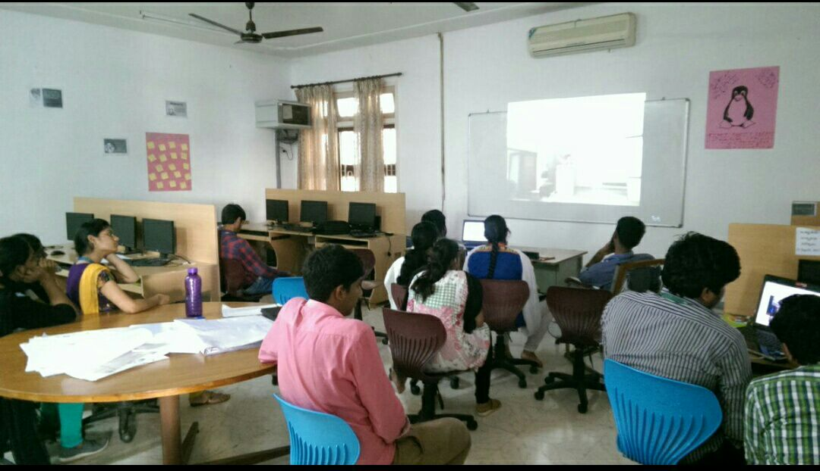

This session is a webinar by P.Sainath who is an Indian journalist and photojournalist who focuses on social & economic inequality, rural affairs, poverty and the aftermath of globalization in India has expressed his views from his experience on Rural India and Digital Age

21st March 2017
Session on WebVR and FOSS lincenses
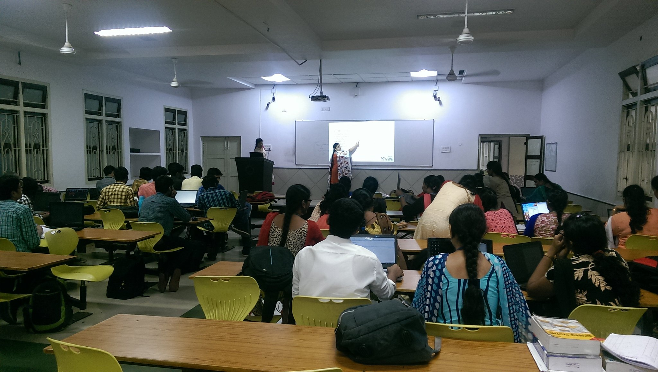

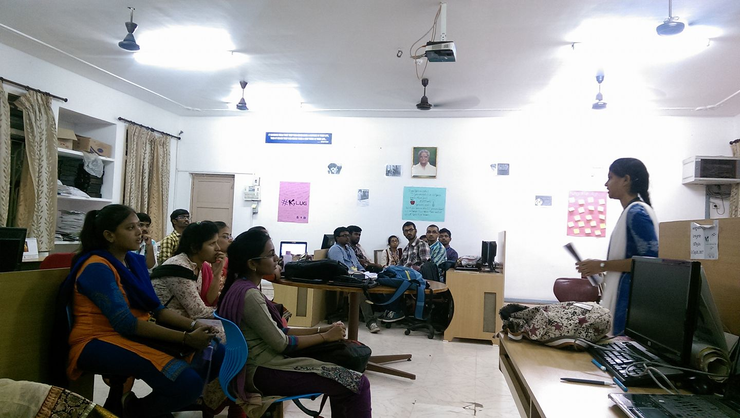

A Session on WebVR and different FOSS licenses

23rd March 2017
Tribute to Bhagat Singh

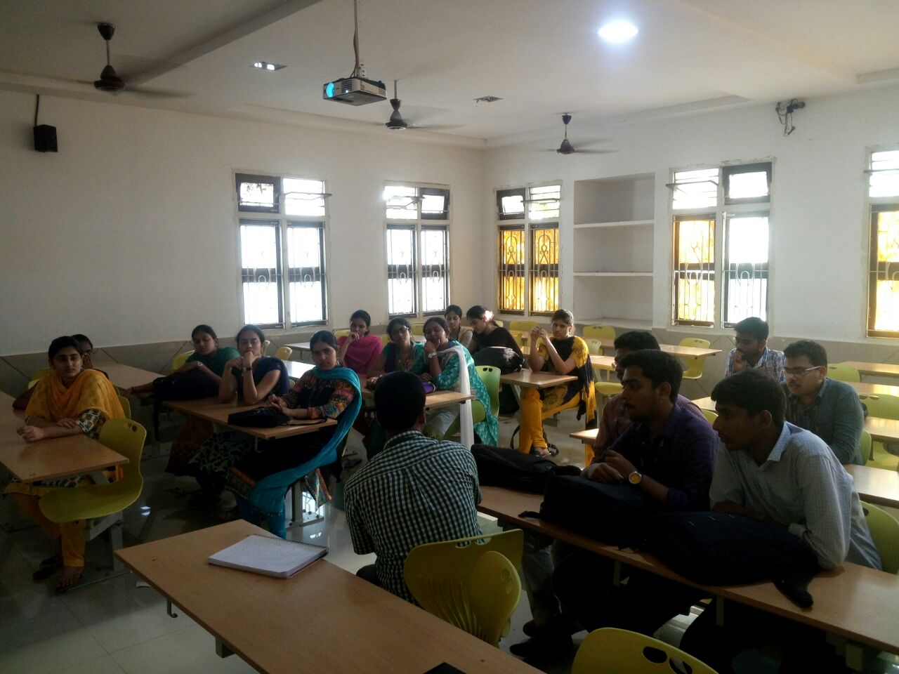

23rd March is observed as Martyrs’ Day in honor of Bhagat Singh, Rajguru & Sukhdev. A salute to our martyrs for giving up their lives during freedom struggle so that subsequent generations could live in peace & prosperity.KLUG initiated the day and described people about the struggle they did

28th March 2017
Selenium and Agile Methodology

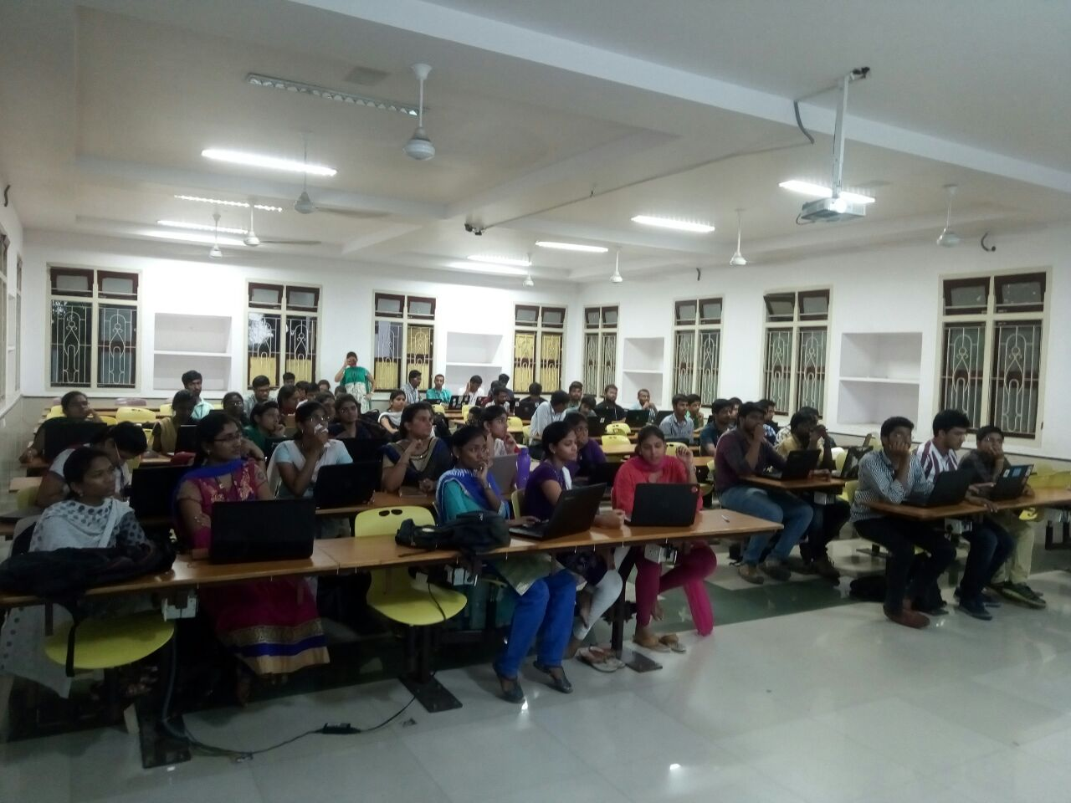

This session deals about different emerging technologies that are extensively used in the industries.

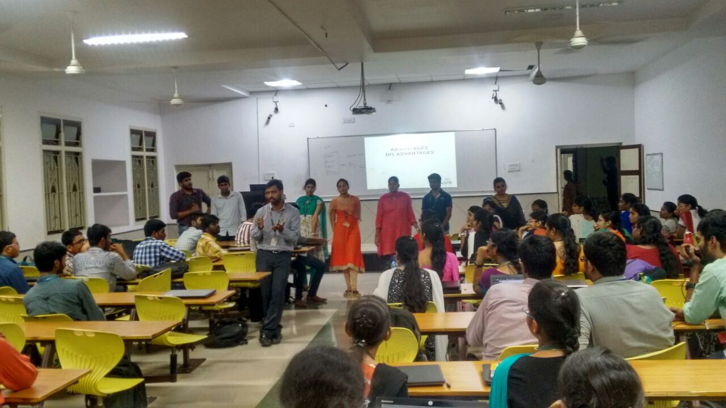

9th April 2017
Talk on WikiLeaks Vault 7

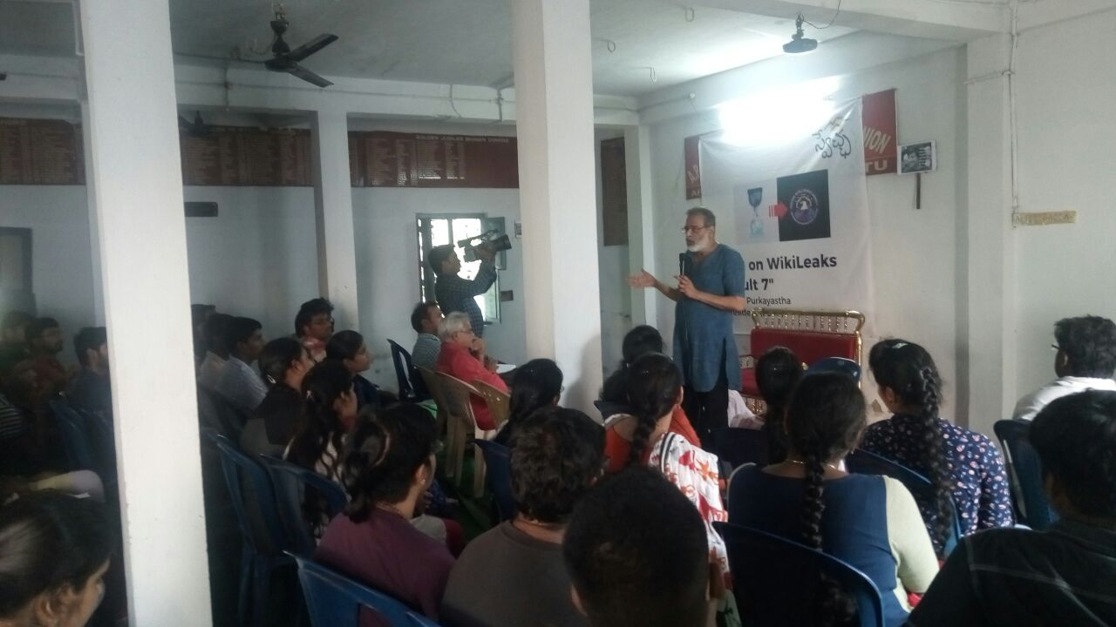

A Talk on WikiLeaks Vault 7 by Mr.Prabir Purkayastha,President FSMI (Free Software Movement of India) held in vijayawada many KLUG students attended the event and expressed their views on Vault 7

